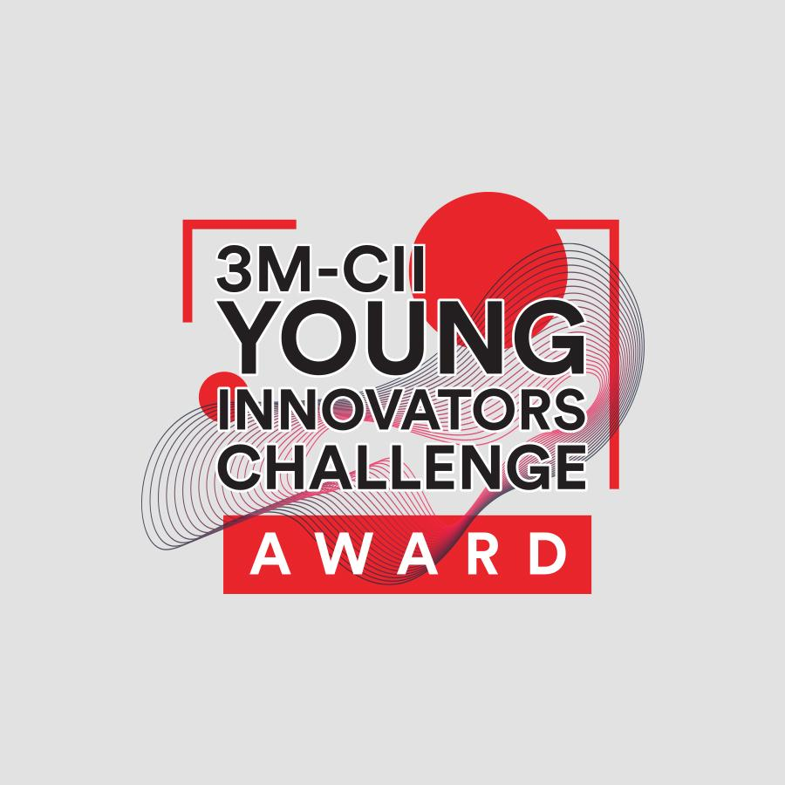

**Entry Form**

Welcome to 3M-CII “Young Innovators Challenge Awards 2019”!

This is your opportunity to showcase your innovation/idea to our multi-stakeholder community and win recognition & support for the furtherance of your vision. Take a moment to:

* Read the Challenge Overview, Guidelines, Participation Eligibility and Assessment Criteria carefully. These resources will help you focus your idea pitch for the entry.
* Tell us about the social impact of your idea and how do you plan to take it forward.
* Bring your story to life! Upload videos and documents via Google Doc links in support of your entries.
* Pay attention to all-star marked questions as your response to them is mandatory.

Take your time to build a strong entry — you can send us your submissions both offline and online. All offline submissions should be sent to [3myounginnovatorschallenge@gmail.com](mailto:3myounginnovatorschallenge@gmail.com) while online submissions should be made through this [online form](http://www.3myounginnovatorschallenge.com/online-entry-form/). **The** **deadline for submission of entries is 30th June 2019.** This Challenge is an opportunity for you and you must make the most of it!



**Challenge Overview**

**3M-CII “*Young Innovators Challenge Awards 2019*”** theme is **“Disruptive Innovations to Create Social Impact”**. Disrupting the cycle of entrenched social issues can be the tipping point of the world and innovation has the ability to drive massive improvements to impact positive social change. Quoting Clayton M. Christensen and his book The Innovator’s Dilemma, “winner-take-all game where one technology replaces another or where a business that does the job faster and cheaper replaces an existing, lucrative one. It’s about game-changing, curve-bending opportunities to drive impact—not necessarily through technologies, but through vision, adaptation, and a die-hard commitment to collaboration”. In this context, the “Challenge” is looking for innovation that has the ability to either displace an existing situation to replace it with positive change or alter the status quo with variables that can create improvement in impact. In short, 3M-CII “*Young Innovators Challenge Awards 2019*” is searching for disruptive innovations that can drive growth strategies of sustainable living starting from India across the world.

The Challenge encourages the submission of ideas and projects off the ground but at an early stage, in the areas of health, education, livelihood, environment, art & culture, governance and/or inclusive development. As every year, 3M is not only looking at products, services or technology as solutions but also as practices and initiatives that have the potential to generate a shift in people’s thinking to drive positive change.

3M runs this effort in collaboration with the Confederation of Indian Industry, every year. The process of participation is both online and offline through a prescribed entry form. There is also the scope of nominating worthwhile innovators from remote rural regions who are unable to access the opportunity on their own. Nominations are open through the challenge website both voluntarily as well as through the “Challenge Team” who outreaches to a rich and diverse network of credible nomination base (institutions and individuals).



**Challenge Guidelines**

The vision of the Challenge is to identify, recognize and support ideas that contribute towards nation-building, sustainable development as well as imbibe the ability to lead the future of the world. Towards this, it is expected that all winning entries:

* Have an idea or initiative which is either on the way to be institutionalized or enterprise journey and layout of a working model that does not rely on philanthropy or aid alone.
* Be capable of sustaining its journey and scale, in case the innovation is at the idea stage
* Demonstrate evidence to create change or mark a valid difference even if based on postulation at the idea stage.
* Demonstrate leadership abilities/capabilities of the participant(s) to drive the innovation
* Include a coherent and credible short term plan (one year) for the idea/innovation.
* Indicate the difference the award prize and recognition would make to the initiative/innovation.

The Challenge is open to submissions from anywhere in India, but the participating innovations, ideas and initiatives must specifically apply to the Indian context.Also, 3M is continuing towards awarding disruptive innovations and a more inclusive outreach towards rural innovation which has a meaningful impact which can be measured either qualitatively or quantitatively in the context. ***Participation for this category is via nomination. Self-nomination is accepted. Please write to the “Challenge” team to access the nomination for at*** [3myounginnovatorschallenge@gmail.com](mailto:3myounginnovatorschallenge@gmail.com)***.***



**Participation Eligibility**

***Ideas under Product and Service Innovation Categories:***

* The Challenge is open to individuals, teams and organization having an idea of any impactful innovation.
* Age bar of the participating innovators, team members and organization’s founders’ should be between 18 to 30 years as on or before 15th July 2019.
* All participants should be Indians or reside in India as permanent residents.
* Ideas presented could be at a conceptual stage with demonstrated proof of concept and plans for institutionalizations. Also, submissions are invited from early stage innovations who have begun their institutionalization journeys but their enterprises are less than 3 years of age.
* Entries cannot be accepted from current 3M employees, interns or trainees nor can entries promote 3M or its products.
* Applications must be submitted in English.
* All ideas must be original and **shouldn't have won any awards previously.**

*General Terms for Nominations: WHO SHOULD BE NOMINATED?*

* Nominations are intended for grassroots level individuals or innovators who are either from rural areas or semi-urban areas and who have excelled as social change leaders. Their solutions should have the ability to demonstrate positive change or improvement in the lives of remote rural or semi-urban communities.
* The nominee(s) may run their own initiative or organization or be part of larger forum or networks. Alternatively, they could be working as an individual volunteer or be part of the local government system (i.e. a panchayat).
* **Nominee(s) who have won any major National or State awards (such as Chief Minister’s and Corporate Awards) will not be eligible for nomination.**

*Who can Nominate?*

* Self-nominations are accepted with the recommendation from credible community reference such as district administration or local NGO / CBO.
* Organizations, networks and any individual can submit a nomination for a credible remote innovator with worthwhile reference for due diligence. Nominee credentials are compulsory (i.e. direct email and mobile numbers)
* All nominations should adhere to the age criteria of the “Challenge” that is mentioned in the eligibility section.



**Assessment Criteria:**

***Product and Service Innovations:***

* **Concept:** Conceptualization is the basis of a powerful idea. The concept has to be dynamic in nature which can lead to an evolutionary change in the long run. Best entries, through their innovation, will not only address a need or solve a problem but also seize an opportunity for growth and leadership in a new space. The ideas presented must hence be expansive of their overall plan of design, development and implementation.
* **Innovation:** We are looking for the “game-changers” or “change-makers” for nation building and those who could lead the future of the world with their idea. The best entries will demonstrate how through creative approaches and solutions, an existing need or problem is being solved. However, problem-solving need not seek permanent intervention, but temporary intervention with a long-lasting appeal. The innovation must be able to present evidence of various distinctive advantages over alter alternatives. Additionally, the submissions must propose a unique value proposition in relation to the cost of opportunity versus economic desirability for its benefits. Such solutions (be it a product, application, service or practice/initiative or hybrid combinations of existing tools) must be capable of being prototyped. Ideas presented does not have to involve inventing something entirely new, but entries should describe how ideas are original.
* **Measurable Impact:** Entries should be able to explain how the idea has the ability to deliver positive measurable impact on people at large (e.g. accessibility or affordability or inclusiveness). The best projects will tackle a significant sustainability issue and will have the potential of making a large scale difference with a futuristic vision.
* **Financial Sustainability:** Ideas presented should have a clear plan for reaching long-term goals. The strongest entries will outline how their solution can be sustained without reliance on philanthropic donations or aid for core funding. If ideas are already at work, it should demonstrate fiscal responsibility and marketplace validation.
* **Governance:** To ensure and identify how well the innovative idea can be incorporated into the practical scenario of various parts of the country also if it is ideal to get collaborated with other entities. Further engagement of the citizens in order to implement the same is also analyzed.
* **Potential:** The potential to which the project, idea or the innovation can be scaled in order to have an impact for the greater mass is also a major concern. To implement the ideas into a stronger network so that the purpose of launching the idea has an impact.

***Nominations for Rural Innovations:***

The nominated youth-led rural innovations will be assessed on the following criteria:

* Vision and leadership (including personal journey or the motivation behind the idea)
* Concept and approach for addressing the identified social problem
* Profile of Beneficiaries Targeted (i.e. while the idea must adhere to the rural context, the target audience will also be important criteria to evaluate relevance, inclusiveness and futuristic approach in developing last mile communities)
* Ability to create multi-level partnerships for sustaining the innovation for long term
* Impact and milestones either achieved or planned

*India has the potential to lead the world’s growth by providing new and inclusive models of development that have inherent process efficiency, systemic sustainability and scope based tech-integration. This Challenge is an effort to unearth such ideas and put them on India’s innovation map.*



There are two prizes under each category - **Idea Prize** (for innovations that have a clear impact stated) **and Impact Prize** (for ideas at work and generating measurable impact)**.**

**Total of 6 prizes worth INR 15,00,000 to be won.**

**START YOUR SUBMISSION**

***Submission Title: (Title your Project)***

## ***Which category does this submission best fit into? \** *Please highlight any one.***

* **Product Innovation**
* **Service Innovation**

**To make a nomination under “Rural Innovation”, please write to the “Challenge Team” at** [3myounginnovatorschallenge@gmail.com](mailto:3myounginnovatorschallenge@gmail.com)***.***

* **Rural Innovation** is most inclusive in nature and spread across almost everything but should specifically address rural and remote communities and/or regions. The ideas under this category are expected to add new economic or social value to rural life. All submissions should be nominations.

**How to choose your category?**

* **Product Innovation** is defined as the creation or introduction of a good or service that generates unique value to its audience. Product innovation must offer a tangible end result. E.g. product invention, new technical specification or qualitative improvement that impacts the functioning of the solution offered.
* **Service Innovation** could be a service product or service process that is based on some technology or systematic method. E.g Distribution process, use of technology for delivery of service etc. Though the innovation itself could be intangible, however, the impact it creates should have a clear definition.

***Why do you think your idea fits into the category you have selected? Explain in detail.***

# ***Participant Details\**** *Maximum 3 member team can apply. Tell us about yourself*

|  |  |  |  |
| --- | --- | --- | --- |
|  | **<Team member 1>** | **<Team member 2>** | **<Team member 3>** |
| **Name** |  |  |  |
| **Date of birth** |  |  |  |
| **Institution / Organization** |  |  |  |
| **Email** |  |  |  |
| **Phone / Mobile #** |  |  |  |
| **Skype Name** |  |  |  |
| **Facebook (if any)** |  |  |  |
| **Twitter (if any)** |  |  |  |
| **LinkedIn (if any)** |  |  |  |
| **Website (if any)** |  |  |  |

***Reference for your submission:\**** *Atleast one reference is mandatory!*

*Please provide the name, email address, and phone number of someone who knows your initiative or idea well, such as your academic institution or funder or investor. (confidential)*

|  |  |  |  |
| --- | --- | --- | --- |
|  | **Reference 1** | **Reference 2** | **Reference 3** |
| **Name** |  |  |  |
| **Institution / Organization** |  |  |  |
| **Email** |  |  |  |
| **Phone / Mobile #** |  |  |  |

**About the project or idea:** This section is very important as it gives the first preview to the innovation presented based on the description provided here. Please articulate well and keep the word count short.

***What stage is your idea/innovation at?***

* Conceptual with proof of concept
* Pilot/Prototyping
* Institutional Underway
* Enterprise less than 4 years
* Enterprise more than 4 years

***Tell us about your idea/innovation briefly. \**** *Share a concise summary of your IDEA within 3 - 4 sentences. State relevance of the innovation (what problem will it solve), its utility & impact*

**What makes your idea unique?**

***Please share the proof of concept of your idea/innovation. (Please describe how are you working on this idea, not more than 1000 words)***

***Tell us about the social impact of your innovation. Please include real numbers if idea is at work already and hypothetical metrics if still in the concept stage. Evidence of impact is important.*** *Please include real numbers if the idea is at work already. Please state clear instruments to measure impact if the submission is at concept stage.* ***Evidence of impact is important****.* (Help us understand how this impact is socially relevant and can be monitored. Summarize in 350 words or fewer)*

***Where and how do you plan to implement and execute your idea in the next 1 year? \****

Summarize in 250 words or fewer. Please do include specific milestone(s) that you are expected to

achieve in the next 6 months.

***Has your idea/innovation received any awards or recognition previously?\****

* **Yes**
* **No**

***Affirmation & Acknowledgment \****

By entering this Challenge, I affirm that all information presented herein is truthful and accurate to the best of my knowledge and that I have read and accepted the terms and conditions stated in the Challenge Guidelines. I acknowledge that the Challenge Team reserves the right to conduct due diligence or contact external references to verify information provided by the participant. By submitting my entry and supporting materials, I agree that any prize money awarded shall be spent in furtherance of the purposes of my entry. By submitting any information, data, text, software, music, sound, photographs, graphics, video, messages and other materials ("Content") in this Challenge, I grant to the Challenge Team a nonexclusive, perpetual, irrevocable, fully paid up, royalty free license to use, translate, reproduce, modify, publish, publicly distribute, import, publicly display, publicly perform, digitally perform, create derivative works of and otherwise exploit such Content (including any copyrights, trademarks or other intellectual property contained therein), and the right to sub- license the foregoing rights (through multiple tiers) to third parties. I accept these conditions Confidentially and will not be publicly displayed.

**Do you agree with the above?**

*Type Yes or no*

**Thank you for your submission. We will stay in touch with you via your email mentioned in the**

**form as well as SMS (if you prefer) \*** *Highlight all that apply.*

* I want to receive both email and SMS
* I want to receive only email



**End of the entry form.**